Dataset
rnd_room_c2_03:
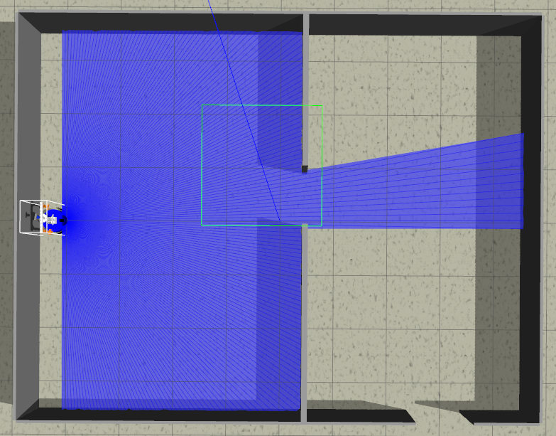
samples
1)
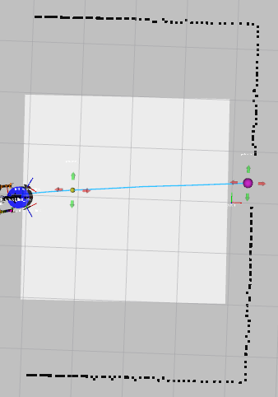
linea recta a puerta 4.4m (x2) (-4.1 0.0 0) to (0.3, 0.4)
files: data_from_path_2025-02-26_18-58-13 to data_from_path_2025-02-26_18-58-29

2)
inea recta a puerta 4.4m (x2) (-4.1 0.0 PI) to (0.3, 0.4)
files: data_from_path_2025-02-26_18-59-35 to data_from_path_2025-02-26_18-59-52

3)
inea recta a puerta 4.4m (x2) (-4.1 0.0 1.57075) to (0.3, 0.4)
files: data_from_path_2025-02-26_19-01-36 to data_from_path_2025-02-26_19-01-52

4)
inea recta a puerta 4.4m (x2) (-4.1 0.0 -1.57075) to (0.3, 0.4)
files: data_from_path_2025-02-26_19-02-30 to data_from_path_2025-02-26_19-02-47

5)
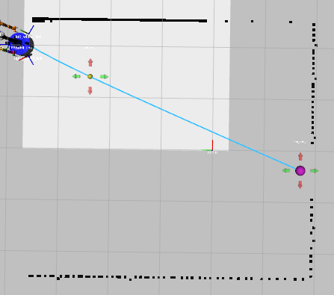
esq inf izq a puerta 5.1m (x2) (-4.1 3.1 0) to (0.3, 0.4)
files: data_from_path_2025-02-26_19-08-59 to data_from_path_2025-02-26_19-09-16

6)
esq inf izq a puerta 5.1m (x2) (-4.1 3.1 PI) to (0.3, 0.4)
files: data_from_path_2025-02-26_19-21-34 to data_from_path_2025-02-26_19-21-51

7)
esq inf izq a puerta 5.1m (x2) (-4.1 3.1 1.57075) to (0.3, 0.4)
files: data_from_path_2025-02-26_19-23-06 to data_from_path_2025-02-26_19-23-23

8)
esq inf izq a puerta 5.1m (x2) (-4.1 3.1 -1.57075) to (0.3, 0.4)
files: data_from_path_2025-02-26_19-24-05 to data_from_path_2025-02-26_19-24-24

9)
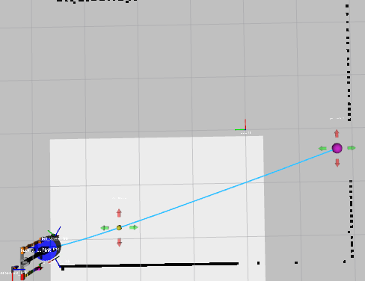
esq inf der a puerta 5.6m (x2) (-4.1 -3.1 0) to (0.3, 0.4)
files: data_from_path_2025-02-26_19-25-59 to data_from_path_2025-02-26_19-26-34

10)
esq inf der a puerta 5.6m (x2) (-4.1 -3.1 PI) to (0.3, 0.4)
files: data_from_path_2025-02-26_19-28-51 to data_from_path_2025-02-26_19-29-09

11)
esq inf der a puerta 5.6m (x2) (-4.1 -3.1 1.57075) to (0.3, 0.4)
files: data_from_path_2025-02-26_19-30-11 to data_from_path_2025-02-26_19-30-28

12)
esq inf der a puerta 5.6m (x2) (-4.1 -3.1 -1.57075) to (0.3, 0.4)
files: data_from_path_2025-02-26_19-30-56 to data_from_path_2025-02-26_19-31-14

13)
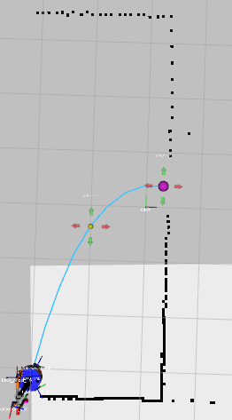
centro der a puerta 4.2m (x2) (-2 -3.1 0) to (0.3, 0.4)
files: data_from_path_2025-02-26_19-37-13 to data_from_path_2025-02-26_19-37-33

14)
centro der a puerta 4.2m (x2) (-2 -3.1 PI) to (0.3, 0.4)
files: data_from_path_2025-02-26_19-38-07 to data_from_path_2025-02-26_19-38-25

15)
centro der a puerta 4.2m (x2) (-2 -3.1 1.57075) to (0.3, 0.4)
files: data_from_path_2025-02-26_19-39-02 to data_from_path_2025-02-26_19-39-21

16)
centro der a puerta 4.2m (x2) (-2 -3.1 -1.57075) to (0.3, 0.4)
files: data_from_path_2025-02-26_19-39-50 to data_from_path_2025-02-26_19-40-07

17)
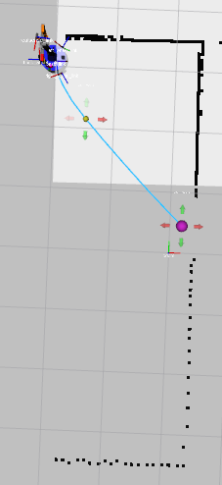
centro der a puerta 3.4m (x2) (-2 3.1 0) to (0.3, 0.4)
files: data_from_path_2025-02-26_19-50-02 to data_from_path_2025-02-26_19-50-18

18)
centro der a puerta 3.4m (x2) (-2 3.1 PI) to (0.3, 0.4)
files: data_from_path_2025-02-26_19-51-11 to data_from_path_2025-02-26_19-51-27

19)
centro der a puerta 3.4m (x2) (-2 3.1 1.57075) to (0.3, 0.4)
files: data_from_path_2025-02-26_19-52-07 to data_from_path_2025-02-26_19-52-23

20)
centro der a puerta 3.4m (x2) (-2 3.1 -1.57075) to (0.3, 0.4)
files: data_from_path_2025-02-26_19-53-03 to data_from_path_2025-02-26_19-53-27

21)
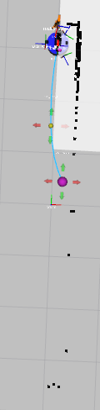
esq sup izq a puerta 2.6m (x2) (0.0 3.1 PI) to (0.3, 0.4)
files: data_from_path_2025-02-26_19-58-08 to data_from_path_2025-02-26_19-58-23

22)
esq sup izq a puerta 2.6m (x2) (0.0 3.1 0) to (0.3, 0.4)
files: data_from_path_2025-02-26_19-58-48 to data_from_path_2025-02-26_19-59-04

23)
esq sup izq a puerta 2.6m (x2) (0.0 3.1 -1.57075) to (0.3, 0.4)
files: data_from_path_2025-02-26_19-59-49 to data_from_path_2025-02-26_20-00-03

24)
esq sup izq a puerta 2.6m (x2) (0.0 3.1 1.57075) to (0.3, 0.4)
files: data_from_path_2025-02-26_20-00-27 to data_from_path_2025-02-26_20-00-43

25)
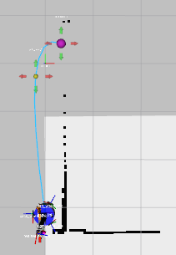
esq sup der a puerta 3.5m (x2) (0.0 -3.1 0) to (0.3, 0.4)
files: data_from_path_2025-02-26_20-03-23 to data_from_path_2025-02-26_20-03-45

26)
esq sup der a puerta 3.5m (x2) (0.0 -3.1 PI) to (0.3, 0.4)
files: data_from_path_2025-02-26_20-07-25 to data_from_path_2025-02-26_20-07-44

27)
esq sup der a puerta 3.5m (x2) (0.0 -3.1 -1.57075) to (0.3, 0.4)
files: data_from_path_2025-02-26_20-08-24 to data_from_path_2025-02-26_20-08-43

28)
esq sup der a puerta 3.5m (x2) (0.0 -3.1 1.57075) to (0.3, 0.4)
files: data_from_path_2025-02-26_20-09-15 to data_from_path_2025-02-26_20-09-36

29)
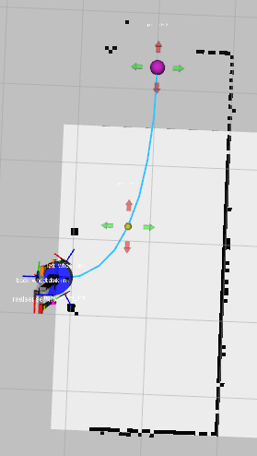
puerta a puerta 4.6m (x3) (0.0 0.3 0) to (2.758, -3.502)
files: data_from_path_2025-02-26_20-14-36 to data_from_path_2025-02-26_20-15-30

30)
puerta a puerta 4.6m (x3) (0.0 0.3 PI) to (2.758, -3.502)
files: data_from_path_2025-02-26_20-22-00 to data_from_path_2025-02-26_20-22-45

-----
Mirror
-----
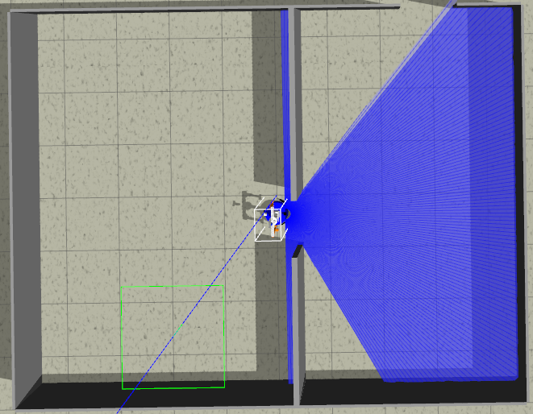
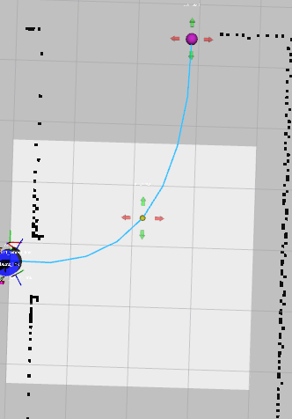

31)
puerta a puerta 4.6m (x3) (0.0 -0.3 0) to (2.758, 3.502)
files: data_from_path_2025-02-26_20-27-36 to data_from_path_2025-02-26_20-30-29

32)
puerta a puerta 4.6m (x3) (0.0 -0.3 PI) to (2.758, 3.502)
files: data_from_path_2025-02-26_20-31-24 to data_from_path_2025-02-26_20-32-45

